Daily Report

Department: Automobile Engineering Date: 26 March 2026

- Staff Attendance:

S. No | Dept. | Category | On Rolls | Absent | Details/Remarks
1 | Automobile Engineering | Teaching | 20 | 3 | Faculty – On Duty  - Mr. Chandrashekhar B Banad  Faculty – Casual / Earn Leave  a. Full Day  - Mr. M. Venkata Ramarao (CL)  - Dr. Shaik Aslam Ansari (CL)  b. Half Day (FN/AN)  Faculty – Half Pay Leave  - Name of the Faculty  Faculty - Study Leave  - Name of the Faculty  Faculty - Maternity/Paternity Leave  - Name of the Faculty (ML/PL)  Leave Without Pay  Break in Service  1.
 |  | Non- Teaching | 07 | 1 | Staff– On Duty  1.  Staff- Casual / Earn Leave  a. Full Day  1. Mr. G. Pundarika (CL)  b. Half Day (FN/AN)  Staff– Half Pay Leave  - Name of the Staff  Staff -Study Leave  1. Name of the Staff  Staff – Maternity/Paternity Leave  1.  Leave Without Pay

- Infrastructure issues or Maintenance:

S.No. | Description of the problem | Reported  On | Attended  On | Completed on | Remarks
1.

- Event (short term course / workshops/Seminar, etc.) organized:

S. No | Name of the Event-seminar/ short term course / workshops, etc. | Duration | For Whom | No. of Participants |  | Resource  Person/Faculty | Remarks
 |  |  |  | VNRVJIET | Others

- Participation by Staff:

S. No | Name | Event | Status (delegate /paper) Present, speaker) | Date and Duration
 | Dr. Shaik Amjad, Professor & Head/AE  Dr. Shaik Aslam Ansari, Head-Industry Institute Relations, VNRVJIET | Visited HITS University, Hindustan University Chennai on 24.03.2026 regarding Royal Enfield centre at VNRVJIET and Also visited Royal Enfield company at Chennai | Completed | 24 March 2026

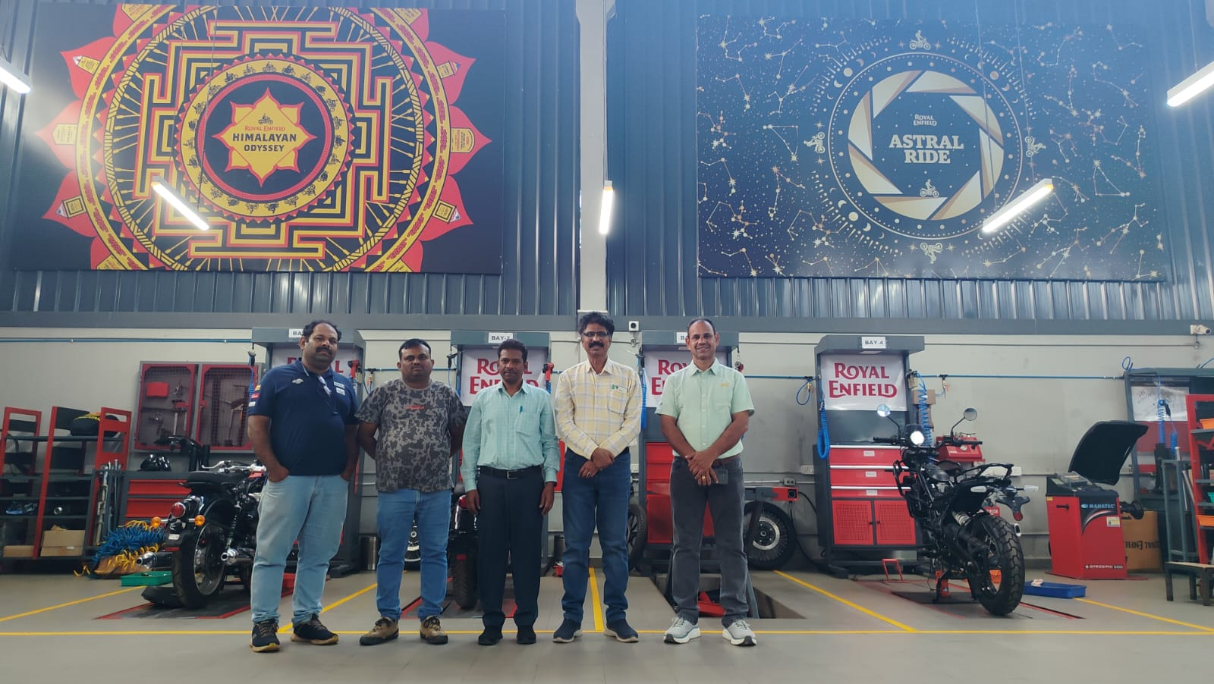

- Participation by Students:

S. No | Name | Event | Status (delegate /paper) Present, speaker) | Date and Duration
 | AKKI KHYATHI SHRADDHA REDDY, Automobile Engineering & 25071A2401 | PADMA BHUSHAN, DR. B. V. RAJU MEMORIAL NATIONAL LEVEL TOURNAMENT  She won 1st place in Badminton Women singles, Badminton Women Doubles & Badminton Mixed Doubles PADMA BHUSHAN, DR. B. V. RAJU MEMORIAL NATIONAL LEVEL TOURNAMENT, by B. V. Raju Institute of Technology, Vishnupur, Narsapur, Medak. | Completed | 23-24 March 2026

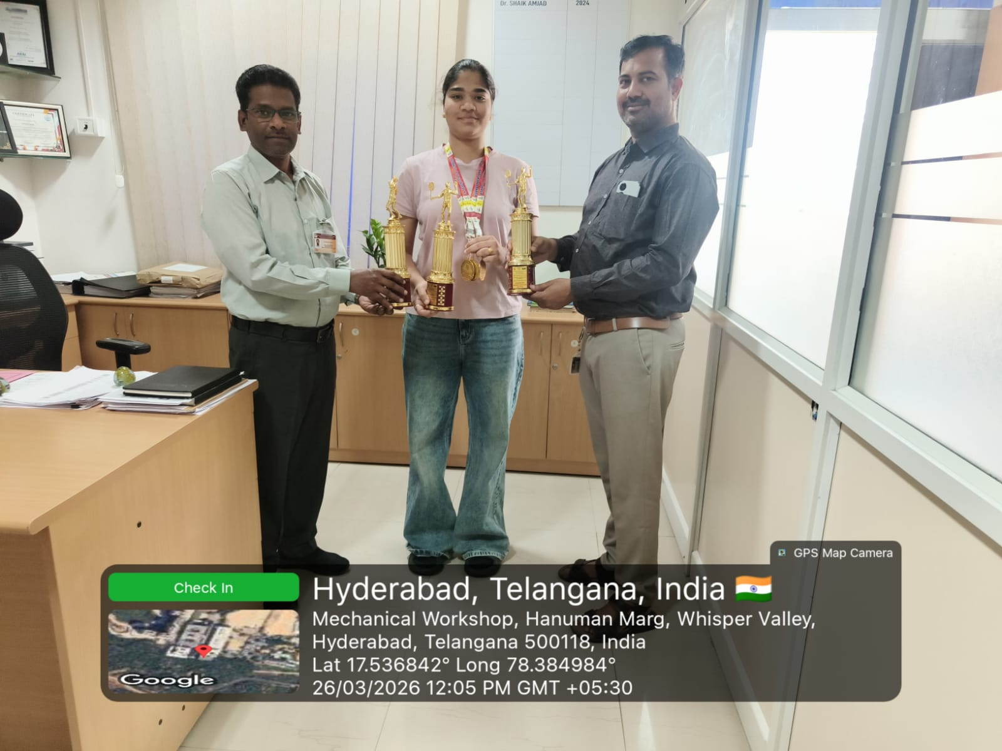

- Staff joined or left

S. No | Name of the Faculty | Designation | Date of Joining/leaving | Remarks

- Classwork Adjustment / Lectures Interchanged:

S. No | Dept | Subject | Time | Adjusted from | Adjusted to
1 | AE | 22PE1AE411-SPECIAL PURPOSE VEHICLES | 10-11 a.m. | 17AED013 - Mutyala Venkata Ramarao | 17AED047 - Manda Krishna
2 | DS-A | 25ES2ME101 - ENGINEERING WORKSHOP | 12.40-3.40 p.m. | 17AED013 - Mutyala Venkata Ramarao | 17AED047 - Manda Krishna
3 | AE | AUTOMOTIVE PRODUCT DEVELOPMENT STRATEGIES | 11-01 p.m. | 22AED085 - Banad Basavaraj Chandrashekhar | Mr. Vinay Kulkarni

- Incident if any (Discipline of staff or students, etc.)

S. No | Name | R. No. or ID No. | Brief statement | Remarks

- Any other matter to be reported:

Did MoU with Trudare Technologies LLP represented by Mrs. P. Sujatha on 25.03.2026.
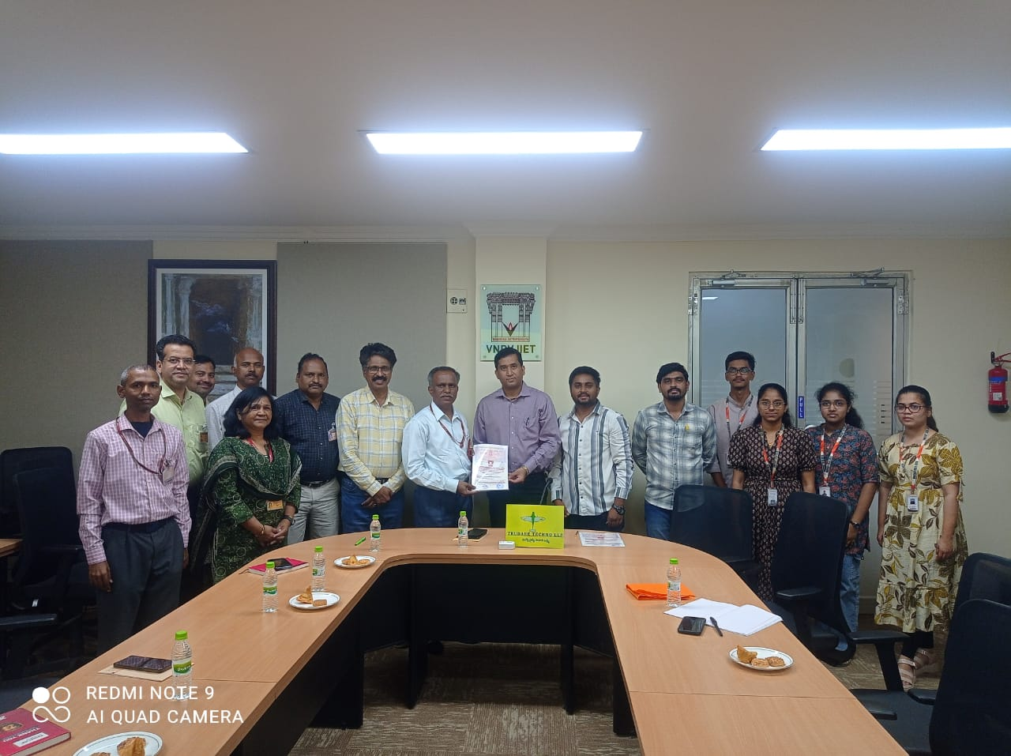
HOD – AE

